CS 471

Lab week 2

Name:جهاد صالح محمد المحسن

ID:421108162

Part 1/task2

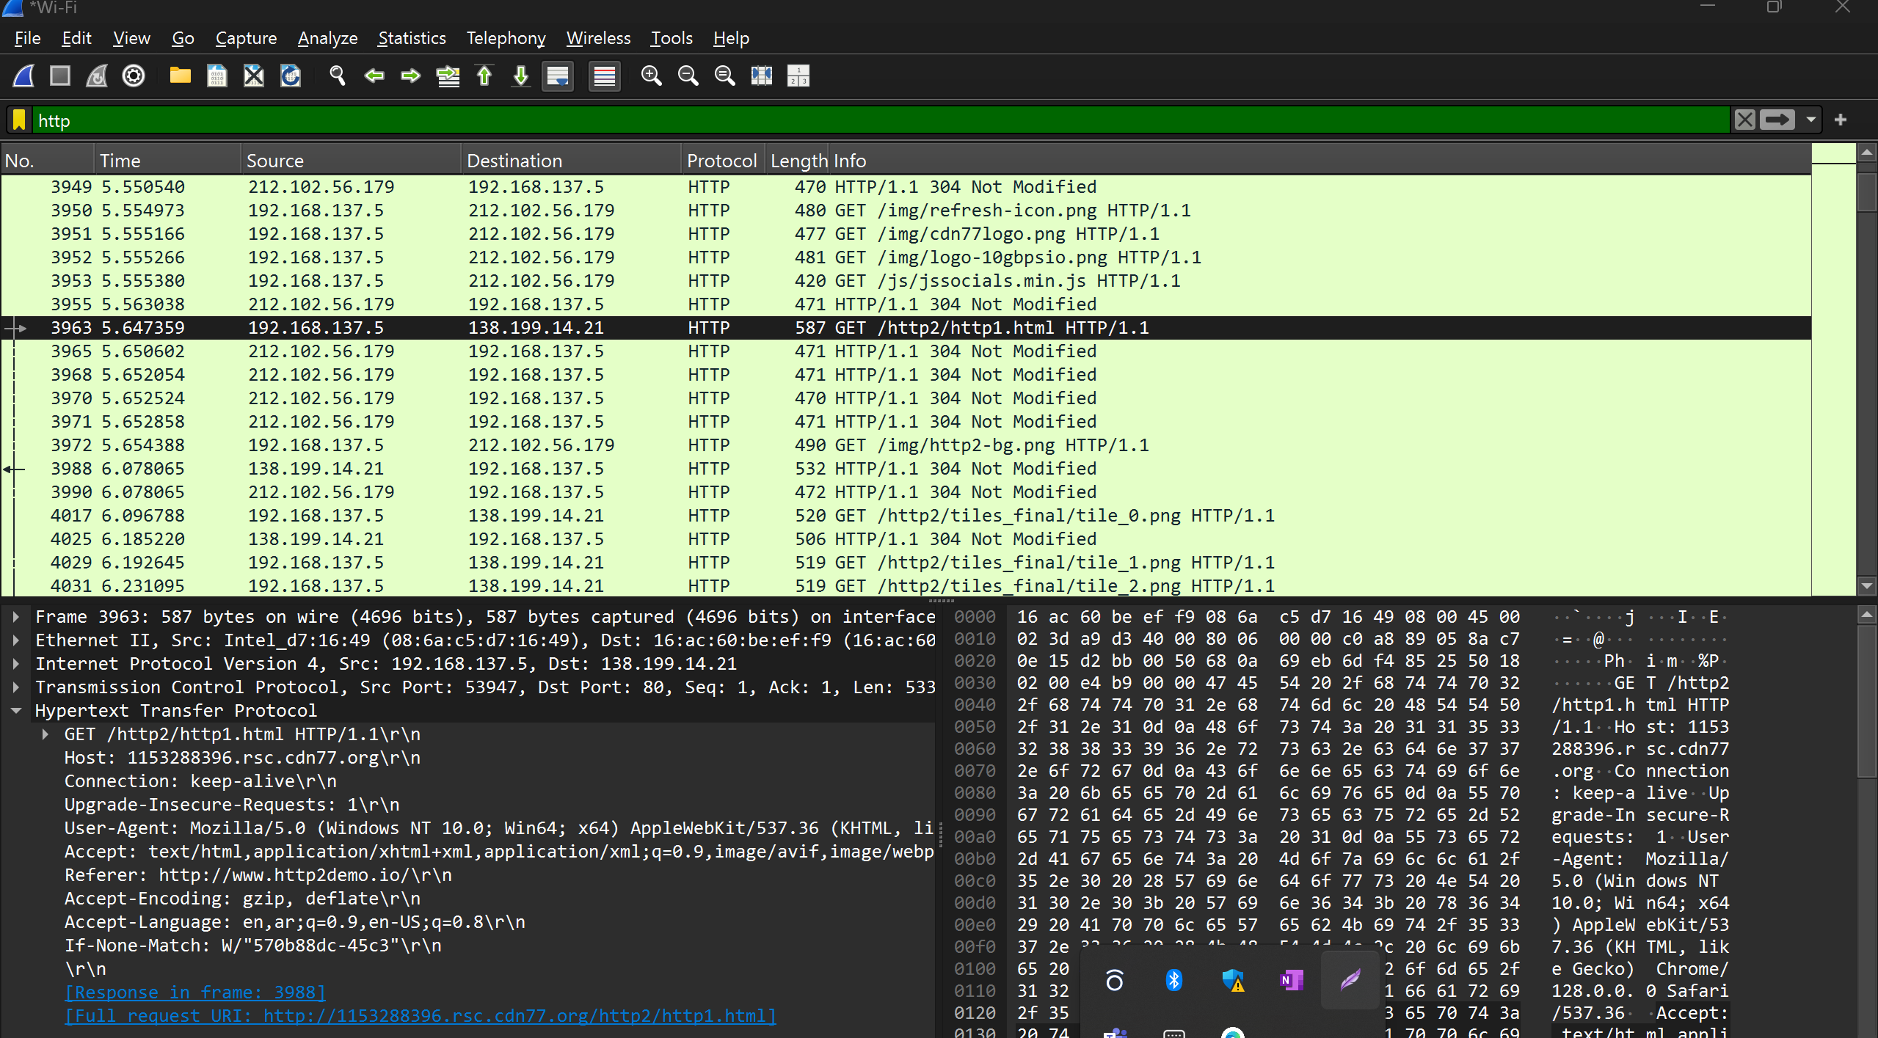

Part1/task1



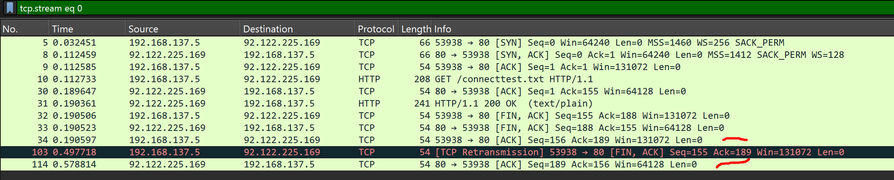

|  |  |  |
| --- | --- | --- |
|  | TCP or UDP | Reasons |
| Reliability and Connection Establishment | TCP | TCP provide more relaiablity connection than UDP because it use three way handshake |
| Data Integrity and Ordering | TCP | TCP use sequence number and acknowledgment to ensure data integrity and ordering are correct |

|  |  |  |
| --- | --- | --- |
|  | TCP | UDP |
| Use cases | Email, Web browsing, File transfer | Streaming, online game, VoIP |
| Performance | Data integrity, Reliable, Bigger overhead | Faster, Smaller overhead, some data is missed |